* **Grouped List**

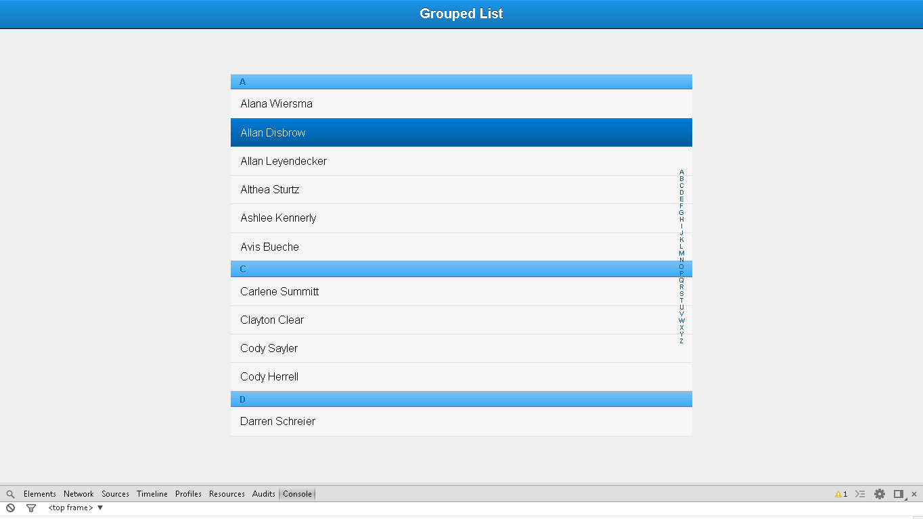

**Snapshot 1.1**

**Code**

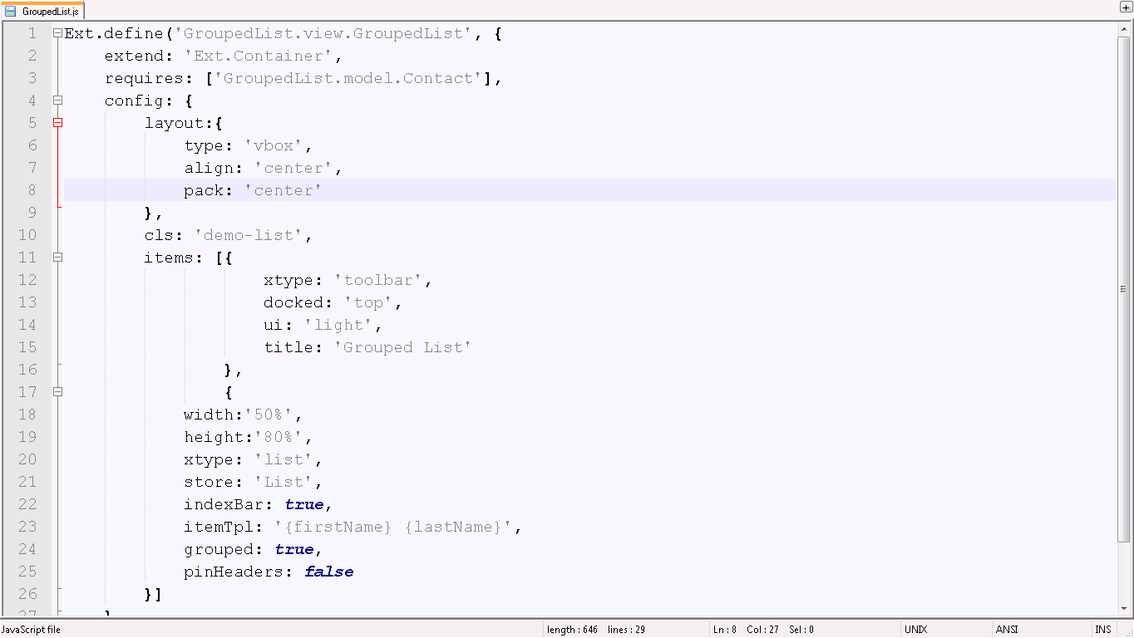

**Snapshot 1.1**

**Ext.define('GroupedList.view.GroupedList',** User defined class GroupedListdefined

**{**

**extend: 'Ext.Container',** :-> Extends to Container (Super class to use in your application)

**requires: ['GroupedList.model.Contact'],** :-> Contact model class is required here which is defined in model folder of DisclosureList application

**config: {**

**layout:** :-> Layout for complete container

**{**

**type: 'vbox',**

**align: 'center',**

**pack: 'center'**

**},**

**cls: 'demo-list',**

**items: [** :-> Title bar for grouped list

**{**

**xtype: 'toolbar',**

**docked: 'top',**

**ui: 'light',**

**title: 'Grouped List'**

**},**

**{**

**width:'50%',**

**height:'80%',**

**xtype: 'list',**

**store: 'List',** store Id is given to use in your application

**indexBar: true,**

**itemTpl: '{firstName} {lastName}',** :-> Item tpl is defined for list

**grouped: true,**

**pinHeaders: false**

**}]**

**}**

**});**

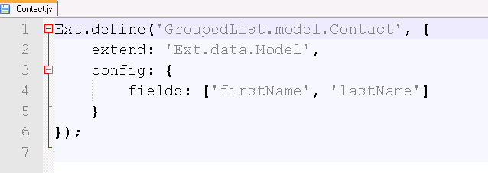

**Snapshot 1.2**

**Ext.define('GroupedList.model.Contact', {**:-> User defined Contact model class is defined

**extend: 'Ext.data.Model',**  :-> Model super class is extended, which is required to define model

**config: {fields: ['firstName', 'lastName'}:**-> Field structure is defined

**});**

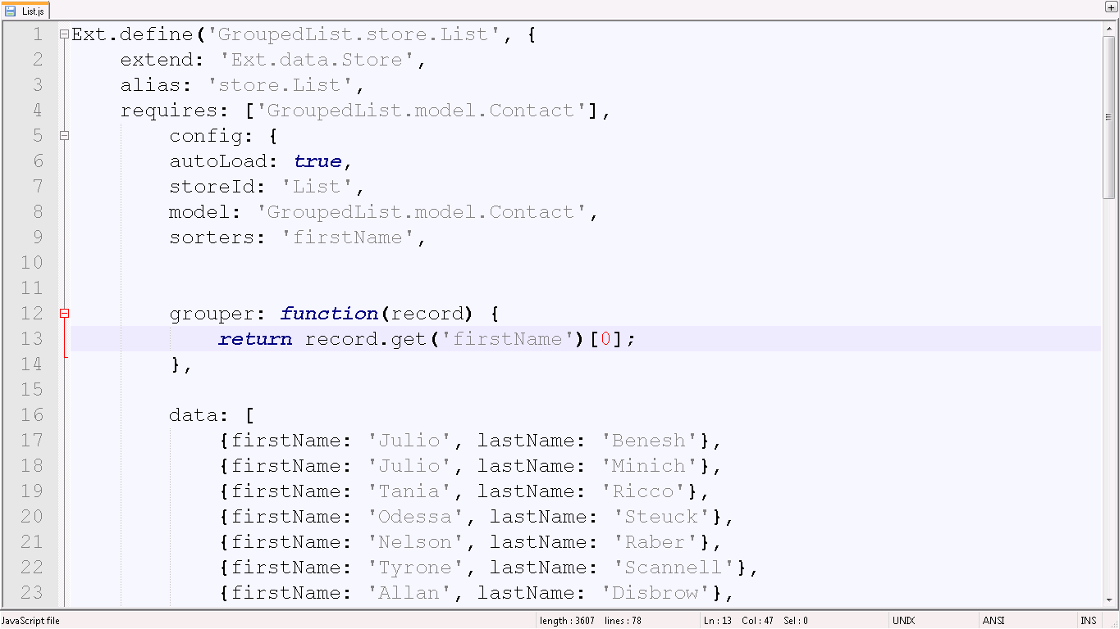

**Snapshot 1.3**

**Ext.define('GroupedList.store.List',** :-> User defined store class is defined

**{**

**extend: 'Ext.data.Store', ,** :-> Super class store is extended which is required to use store

**alias: 'store.List',**

**requires: ['GroupedList.model.Contact'],** :-> Store requires model class to use its field’s structure

**config: {**

**autoLoad: true,** To load list automatically

**model: 'GroupedList.model.Contact',**

**sorters: 'firstName',**

**storeId:'List',** :-> store id is defined

**grouper: function(record) {**

**return record.get('firstName')[0];** :-> Function to return list according to firstName

**},**

**data: [**

**{firstName: 'Julio', lastName: 'Benesh'},**:-> Datalist to include in list

**Checkpoints**

1. Check carefully with your indentations as if you will miss any of the braces by mistake may reflect in compilation error.
2. See that your .js file starts with Ext.Define block and check that ends at the end of the program.
3. More than one items are separated by comma (,) separator and main program block of define is ended by semi colon (;)
4. Any value is assigned using colon (:) for example ui: 'confirm' and value is written inside single coats.
5. Items block starts with square brackets [] , which contains multiple members and also sub items.
6. Don’t forget to add entries of your files in app.js.

**Source Code**

